Application Directions
This NSGP application is intended for organizations interested in applying by email, mail, or in-person delivery. Applicants are encouraged to consider submitting online at https://www.cfgf.org/grantmaking/grant-application/online-grant-application.
To apply by Email, Mail or In-Person Delivery
Complete the NSGP Grant Application
- New applicants and groups / organizations that have not received an NSGP grant in the past three years are NOT required to complete Part 4. Past NSGP Participation of this application.
- Traditional Mini-Grants – Complete the NSGP Application including Attachment A: NSGP Project Planning Worksheet and Attachment B: NSGP Project Budget Worksheet
- Next – Level and Transformational Grants – Completed the NSGP Application including Attachments A, B, and Attachment C: Next Level & Transformational Grant Applications Additional Questions

Submit Applications
- By email to NSGP@cfgf.org by 11:59pm on March 9, 2026
- By mail or in-person delivery by 9:00 p.m. on March 9, 2026 at:

Community Foundation of Greater Flint

500 S. Saginaw Street, Suite 200
Flint, MI 48502
C/O NSGP

NSGP Application
Part 1: Contact & Organization Information 3
Part 2: CFGF Focus Areas 5
Part 3: Application Overview 6
Part 4. Past NSGP Participation 7
Part 5: Project Overview 9
Part 6. Project Description – Narrative 11
Part 6. Partnerships 13
Part 7. COMMITMENT 14
Attachment A: Project Planning Worksheet 15
Attachment B: Project Budget Worksheet 17
Attachment C. Next Level and Transformational Grant Applications 19

Part 1: Contact & Organization Information
ORGANIZATION COMPLETING THE PROJECT
Name of Group / Organization:
Group/ Organization Mailing Address:
Group’s County Registration DBA number or Federal EIN for 501(c)3 organizations: (attach copy of DBA or letter documenting EIN or IRS 501(c)3 status)

FISCAL SPONSOR INFORMATION
Are you working with a Fiscal Sponsor? |  | ☐ Yes, we are working with a fiscal sponsor.  ☐ No, we are not working with a fiscal sponsor.
If yes, please enter the name of the organization serving as your fiscal sponsor:
Fiscal Sponsor Contact Person:
Fiscal Sponsor Contact Email:

CONTACT PERSON #1
Name:
Title:
Mailing Address:
Phone Number:
Email:

CONTACT PERSON #2
Name:
Title:
Mailing Address:
Phone Number:
Email:

When was your group organized?

Service Area:
What are the specific neighborhood boundaries (streets, landmarks etc.) of the area your group or organization serves?

Mission:
What is the mission of your group (the purpose your group was created)?

Organization / Group Changes:
Have there been any significant organizational changes in the past year? (i.e. leadership, board, staffing, location)

Part 2: CFGF Focus Areas

CFGF Focus Areas
The CFGF has identified five focus areas for strategic investment. This section asks applicants to briefly identify how their projects might align to these focus areas. Applicants will be asked to provide more detailed project information in the Project Goals and Implementation section of this application. Visit https://www.cfgf.org/grantmaking/grant-application for more information.

Please select at least one and no more than two focus areas that your project best aligns with.

☐ Economic Mobility
☐ Health Equity
☐ Quality Education
☐ Vibrant Communities
☐ Civic Health

Focus Area Alignment
Please briefly describe how your project aligns with the focus area(s) selected above.

Part 3: Application Overview
Name of Project:

Project Overview:
How would you describe this project in one sentence?

Amount Requested from CFGF: $
Total Program Cost: $
Total program cost includes both the amount requested from CFGF plus the value of any additional funds committed to the project from other sources. This could include other sources of revenue such as grants from other entities, cash donations, and/or the value of in-kind services that will support the project.

NSGP Grant Category:
Please choose one category. Review the NSGP Grant Guidelines to confirm that your proposal meets the requirements of the category selected.
☐ Traditional Mini-Grant (Up to $1,000)
☐ Next Level Mini-Grant (Up to $5,000)
☐ Transformational Grant (Up to $25,000)

Project Start Date:
Click or tap to enter a date.
Project End Date:
Click or tap to enter a date.

Past Participation in NSGP Grant Program
Has your group received grant funding from the CFGF Neighborhoods Small Grants Program (NSGP) in the past 3 years?
☐ Yes
☐ No
If yes, please complete Part 3: NSGP Past Participation. If no, please skip to Part 5.

Part 4. Past NSGP Participation
COMPLETE THIS SECTION IF YOUR ORGANIZATION RECEIVED AN NSGP GRANT IN THE PAST THREEE YEARS / GRANT CYCLES.

Past NSGP Grants
Please provide the year, name, and grant amount for all projects funded by NSGP for the past three years / grant cycles. (i.e. 2025, Cook Park Cleanup $2,500)
Year of Grant Award | Name of Project | Amount Funded

How successful was your group in completing the objectives of your most recent grant project? Please choose one answer below.
☐ Extremely Successful
☐ Successful
☐ Somewhat Successful
☐ Neither Successful nor Unsuccessful
☐ Unsuccessful

If the project was successful, what was the main reason as to why the project was successful?

If the project was unsuccessful, what was the main reason as to why the project was unsuccessful?

If the project was unsuccessful, what was the main reason as to why the project was unsuccessful?

Did your last project experience any unexpected challenges/obstacles?

Did the project have any unexpected rewards/ successes?

Part 5: Project Overview
NSGP Focus Area
Which focus area does your project best fit?
While your project may align with multiple focus areas, you ask that pick only one option below.

☐ Strengthening Neighborhood Groups through Leadership Development/ Technical Assistance
☐ Improving Neighborhood Conditions
☐ Creating Safe Neighborhood Environments
☐ Creating Opportunities for Neighbors to Connect and Engage in Community Activities

Program Outcomes
Which program outcome will your project address the most?
While your program may align with multiple outcomes, you may pick only one option below.
☐ Community Engagement: Getting people involved in neighborhood/community groups or activities
☐ Developing Well-maintained and Inviting Outdoor Spaces: Engaging people in clean-ups, beautification and improvement of public spaces

Project / Program Activities
Which activities will your project consist of? Please complete the table for all activity types that apply.
Activity Type | Number of Activities
Workshops, trainings, conferences, learning exchanges
Neighborhood Watch Activities
Neighborhood Clean-ups
Neighborhood Beautification
Creating Neighborhood gathering spaces
Neighborhood Engagement Events
Neighborhood Art Festival
Other Activities (Please specify):

Number of Participants
Please provide an estimate of the number of people that you anticipate will participate in your project. Attendees include all participants across all activities indicated above. Volunteers may be double counted as attendees.

Example: A proposal for a Neighborhood Festival anticipates 40 attendees plus 5 volunteer coordinators (45 participants total), and Neighborhood Cleanup with 25 attendees who are also volunteers (25 participants total). This proposal would enter a total of 70 attendees and 30 volunteers anticipated in the table below.

Participant Estimates | Number of Individuals
All Attendees
Volunteers

Special Assistance / Training
Would any special assistance or training assist you in developing and carrying out your project? If so, tell us what type of support would be helpful. Check all that apply. You may expand your response in the text box below.

☐ Event Space
☐ Project Planning
☐ Project Reporting
☐ Social Media
☐ Technology / Computer Resources
☐ Youth Engagement
☐ Other (Please describe below)
☐ No training or support is needed.

Please describe any other types of special assistance or training that would be of benefit to your project or program.

Part 6. Project Description – Narrative
Project Description
Describe in detail the project your group wants to do. Please make sure that your description includes the following:
- The type of project
- Where and when the project will take place
- Who will be involved in carrying out the project
- Who will be impacted by the project

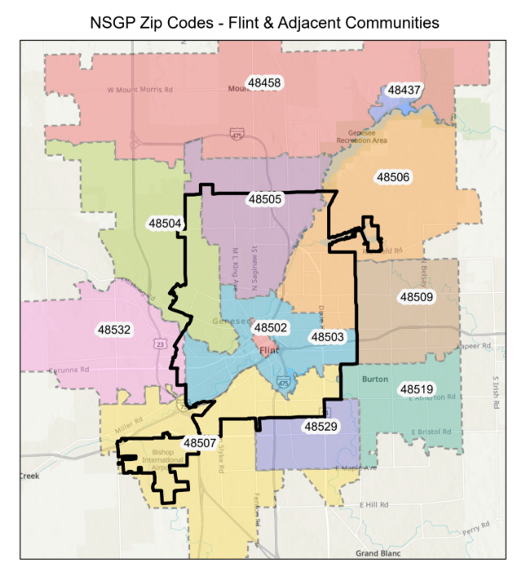
Zip Codes
Please check all of the zip codes where project activities will take place.

☐ 48458
☐ 48502
☐ 48503
☐ 48504
☐ 48505
☐ 48506
☐ 48507
☐ 48509
☐ 48519
☐ 48529
☐ 48532
☐ None of the above

Project Success
How will you know if your project has been successful in bringing about this change?

Project Maintenance
Will your project require maintenance and upkeep throughout the grant period? If yes, describe the plan for maintenance and upkeep.

Part 6. Partnerships
What other groups, businesses, or organizations will you be partnering with to carry-out this project and what will they be contributing (e.g. cash, food, volunteers, meeting space, other donations)? Please be sure to get permission and/or agreement to participate from the partners listed!

Name of Partner Organization/ Business/ Individuals | Partner Contributions | Contact name and phone number of partnering organization/business or  individual

For All Applications:
• Complete Attachment A – Project Planning Sheet
• Complete Attachment B – Project Budget Worksheet

For Next Level and Transformational Grant Applications:
• Also Complete Attachment C

Part 7. COMMITMENT
We understand that funding of this proposal will commit our group/organization to:
1) Complete the activities described in this proposal
2) Actively engage other appropriate parties/individuals in planned activities
3) Engage in project evaluation activities sponsored by the Neighborhoods Small Grants program
4) Share activities and lessons learned with other neighborhoods and the Community Foundation of Greater Flint

Submitted by:

_____________________________________ __________________________________ ___________
Printed Name -Title Signature Date

_____________________________________ __________________________________ ___________
Printed Name -Title Signature Date

The above signatures must be from:
- Neighborhood groups: Two officers of the group
- Nonprofit Organizations: 501(c)3: Executive Director
- Churches/ Faith-based Organizations: Pastor, Bishop, Rabbi, Priest or Head of Governing Body

Proposal Check list:
☐ Completed Application Signed by Officers, Executive Director or Appropriate Head of Governing Body
☐ Copy of DBA, EIN or IRS letter
☐ Completed Attachment A: Project Planning Worksheet
☐ Completed Attachment B. Budget Worksheet
☐ Completed Attachment C. for Next Level Mini-Grant and Transformative Grant Applications Only

Attachment A: Project Planning Worksheet
Name of Group:

Name of Project:

Please list all of the major steps to make your project happen. What will you do first? What will you do second, third, etc.? Make additional copies of this sheet if needed.

 | List All Your Action Steps  (What are the steps/activities that need to be taken to make the project goal happen? How will you make it happen from start to finish?) | Who is Responsible? (Who is assigned to make sure that this step is done?) | Completion Date (When will this action step need to be completed?) | Outcome (O) and Documentation (D) (How are you going to know that the step is done and has been successfully completed? (O)  How will you document it? (D)
1.
2.
3.
4.
5.
6.
7.
8.
9.
10.
11.
12.

Attachment B: Project Budget Worksheet
Name of Group:

Name of Project:

Project Budget Work Sheet Please complete the following budget form. Include all costs associated with this project. If there are additional sources of funding or matching funds (such as other grants) or in-kind support (such as donations of services or materials from area businesses, persons, government or organizations) list them in the appropriate column. Each volunteer service hour is worth $32.87 per hour for adults and $16.44 for children and youth.

Items | Amount Requested | Amount of Cash | In-kind Donations | Total Costs
 |  | from Other Sources | (Type and Value of | (Add the total
 |  | (i.e. dues, other | Donations) | amount across each
 |  | grants, monetary |  | row)
 |  | donations)
1.
2.
3.
4.
5.
6.
7.

Attachment C. Next Level and Transformational Grant Applications

Project Expansion Justification
Please describe in detail the ways that carrying out this project will help your group to move beyond traditional mini-grant projects such as clean-ups and block parties to have a deeper impact in your neighborhood.

Aligning with Community Needs
What method (s) was used to gain input from residents to identify the need that this project will address? (Examples: neighborhood survey, focus group of residents, master plan, census data, community meeting,…).

Ongoing Needs
How will this project be maintained and sustained beyond the grant period?

Please attach sketches, diagrams, photos or any other materials that would provide detail about the following:
• The location of project
• Type and placement of essential project elements (i.e. trees, benches, pavilions…
• Any other additional information that would provide information about the size, scope and intended impact of your project.

