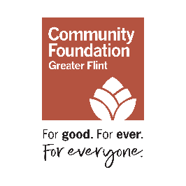
A Step-by-Step Guide
How to Access and Register for the New Grant Portal

We’re excited to announce the launch of our new grant application portal, designed to make the application process more streamlined, accessible, and user-friendly for applicants.
This step-by-step guide is designed to assist you with logging into the grant portal, including where to find portal access on our website, and how to complete the registration steps for yourself and your organization.
Additional Grant Portal Resources:
To learn more about the functionality of the grant portal, browse helpful information, and prepare to register and access the portal, you can also review these resources for applicants.
1) Go to the portal
- Visit the Community Foundation website.
- Click Login (top right corner).
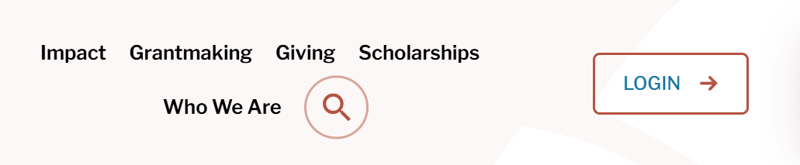
- On the login page, scroll down and click Grant Application Portal.
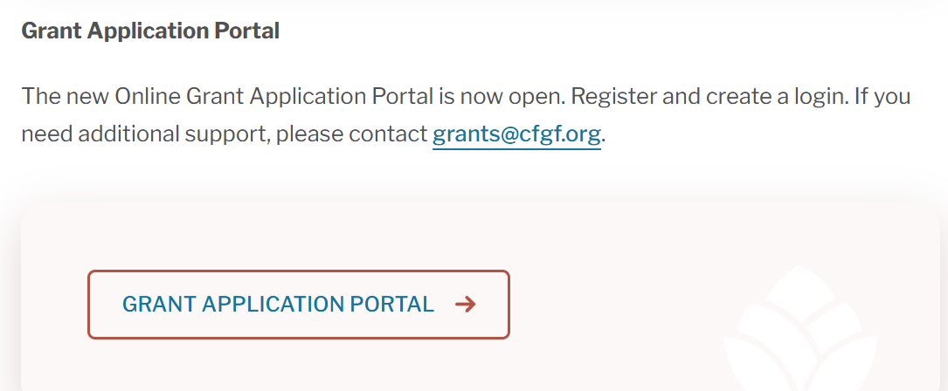
2) Start a new account registration
- On the login/registration page, click Create New Account (all organizations and users must register for the new portal).
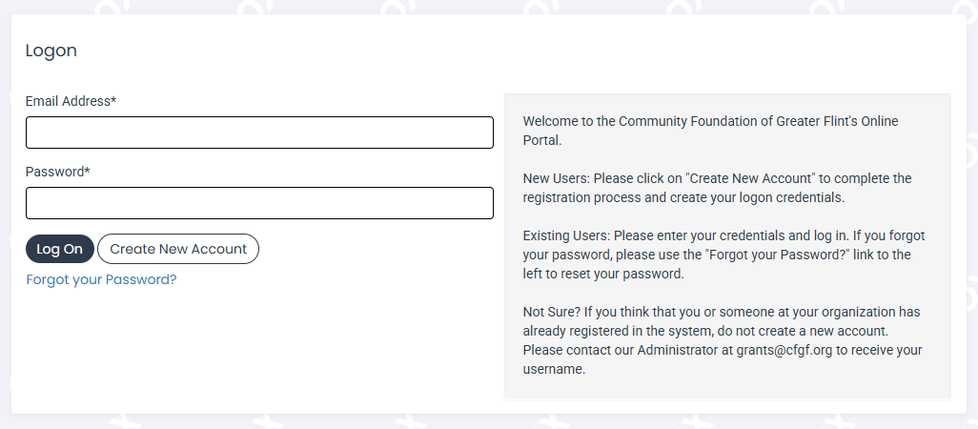

3) Create or connect your organization profile
- Enter your organization information to create an organization profile.
- When prompted, enter your organization’s EIN (what’s an EIN?).
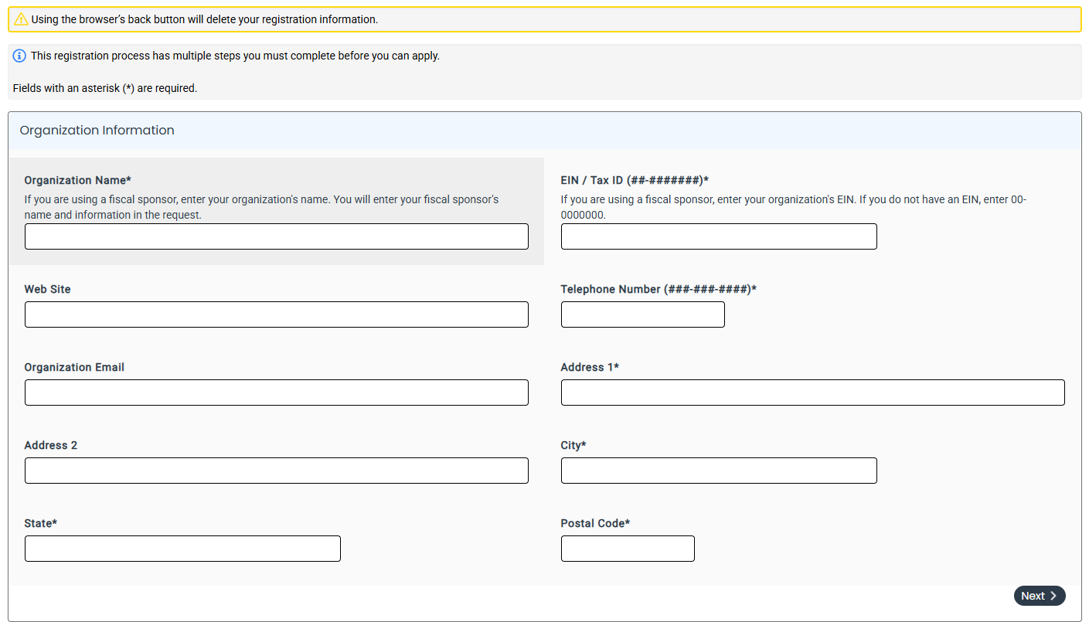

If you see a message that your organization already has a profile stop your registration process.
Follow the instructions in the message to contact CFGF staff at grants@cfgf.org to receive an individual login.
If you do NOT receive that message (meaning the organization profile is new or you are entering all zeros because you do not have an EIN), continue to the next registration section.

4) Complete user contact details
- Enter your contact information.
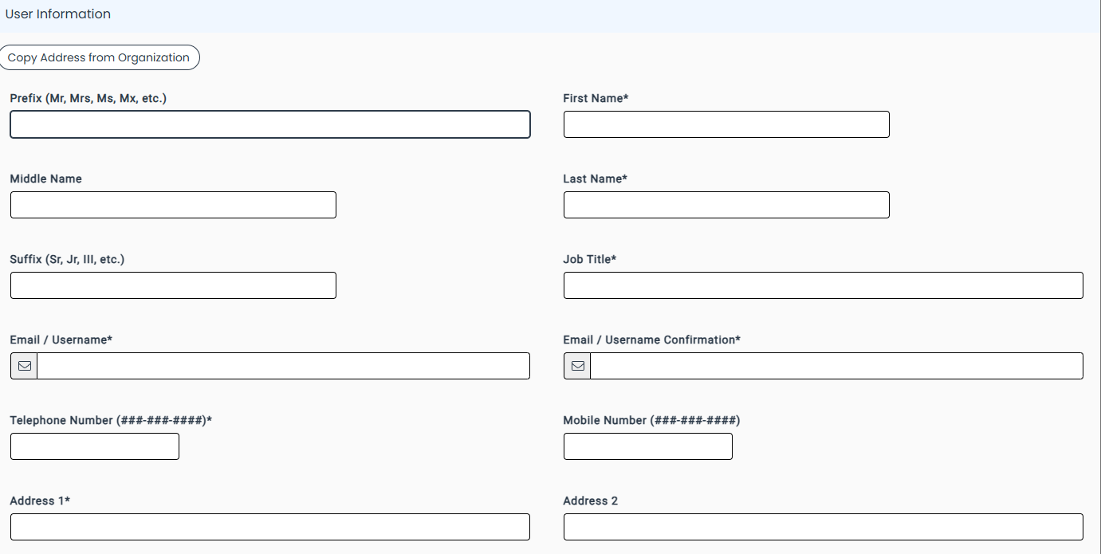

5) Add executive officer details (if needed)
- If you are not the organization’s executive officer (Executive Director/CEO/etc.), an additional section will appear.
- Enter the executive officer’s information.
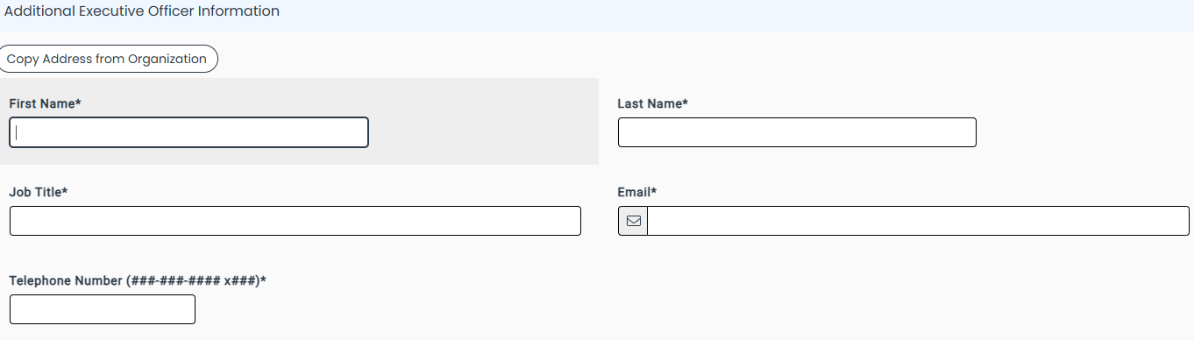

6) Log in and navigate your dashboard
- Log in to the portal.
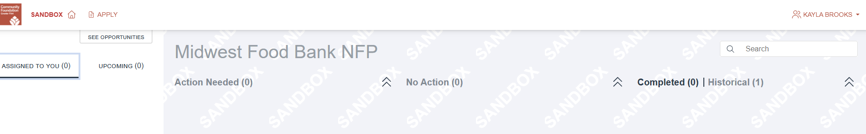
- Your dashboard may be empty at first—it will populate as you begin using the system.

If you have questions about registration and/or login, please contact us at grants@cfgf.org or call 810.767.8270.

